TASK 7 – WAN Technologies

- Create a comparison table listing at least 4 key features of RADIUS and TACACS+ side by side, highlighting which protocol supports each feature.
Ans.
Comparison Between RADIUS and TACACS+

Feature | RADIUS | TACACS+
Protocol Type | Open standard protocol | Cisco-developed protocol
Transport Protocol | Uses UDP | Uses TCP
Encryption | Encrypts only the user password | Encrypts the entire packet
Port Number | UDP 1812 (Authentication) and UDP 1813 (Accounting) | TCP 49
Command Authorization | Limited support | Full command-by-command authorization
AAA Functions | Authentication and Authorization are combined | Authentication, Authorization, and Accounting are separated
Network Access Control | Commonly used for WiFi, VPN, and remote user access | Commonly used for router, switch, and firewall administration
Security Level | Good security | Higher security due to full packet encryption

Explanation
- RADIUS and TACACS+ are both AAA protocols used to control access to network resources. RADIUS is mainly used for authenticating users connecting to WiFi networks, VPNs, and other remote access services. TACACS+ is commonly used to manage administrator access to network devices such as routers and switches.

- Draw a step-by-step flow diagram showing the RADIUS authentication process for a user logging in to a public WiFi hotspot, labeling each communication step between the client, network device, and RADIUS server.
Ans.
Diagram:
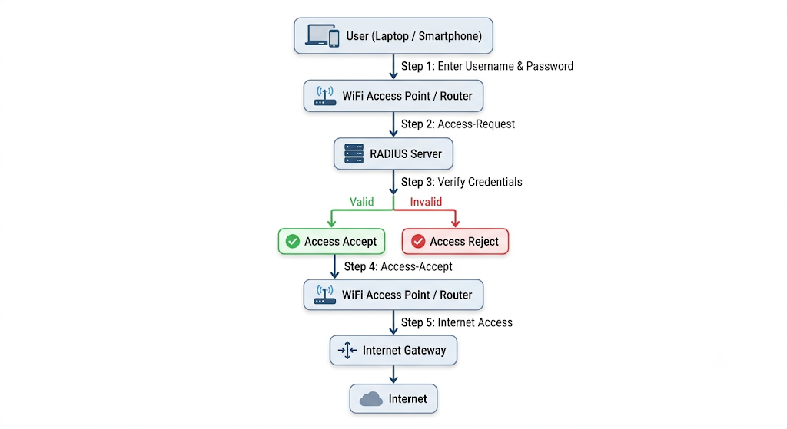
Communication Steps
- User → Access Point: User enters username and password.
- Access Point → RADIUS Server: Sends an Access-Request message.
- RADIUS Server: Verifies the user's credentials.
- RADIUS Server → Access Point: Sends Access-Accept or Access-Reject.
- Access Point → Internet Gateway: Grants network access if authentication is successful.
- Internet Gateway → Internet: User can browse the internet.

3. List 3 real-world use cases where TACACS+ is preferred over RADIUS, and briefly explain why TACACS+ is better suited for each scenario.
Ans.
3 Real-World Use Cases Where TACACS+ is Preferred Over RADIUS
Use Case | Why TACACS+ is Better
1. Managing Routers and Switches in a Large Enterprise | TACACS+ provides command-by-command authorization, allowing administrators to control exactly which commands each user can execute on network devices.
2. Data Center Administration | TACACS+ encrypts the entire packet, providing stronger security when administrators access critical servers, routers, and firewalls in a data center.
3. Network Operations Center (NOC) | TACACS+ keeps detailed logs of every command performed by network engineers, making auditing and troubleshooting easier.

Example 1: Enterprise Network Management
- A company like Flipkart has hundreds of routers and switches. Junior administrators may only be allowed to view configurations, while senior administrators can modify settings. TACACS+ supports this detailed level of control.
Example 2: Data Center Security
- In a data center, administrators manage sensitive infrastructure. TACACS+ encrypts all communication between the device and authentication server, providing better protection against unauthorized access.
Example 3: Network Operations Center (NOC)
- A NOC team monitors and manages network devices 24/7. TACACS+ records every command executed by each administrator, helping organizations track changes and investigate security incidents.

4. Given a scenario where a user tries to log into a network device but fails authentication, describe how RADIUS and TACACS+ would handle the logging and response differently.<br><br><em><strong>Hint:</strong> Focus on how each protocol manages accounting and command authorization.</em>
Ans.
Scenario: User Fails Authentication While Logging into a Network Device
A network administrator tries to log into a router using an incorrect password.
Feature | RADIUS | TACACS+
Authentication Response | Access is denied and the login attempt fails. | Access is denied and the login attempt fails.
Accounting Logs | Records the failed login attempt, user name, time, and device information. | Records the failed login attempt and provides more detailed logging information.
Command Authorization | Limited command authorization support. If login succeeds, command control is basic. | Supports command-by-command authorization. Even after login, each command can be individually controlled and logged.
Audit Capability | Basic user activity tracking. | Detailed tracking of user actions and commands executed on the device.

Explanation
RADIUS
- When the administrator enters the wrong password, the RADIUS server rejects the authentication request. The failed login attempt is recorded in the accounting logs, including the username and timestamp. Since the user is not authenticated, access to the router is denied.
TACACS+
- When the administrator enters the wrong password, TACACS+ also rejects the login request. The failed attempt is logged with detailed information. TACACS+ provides stronger auditing capabilities and can track individual commands if the user successfully authenticates later.

5. Use ChatGPT or another AI tool to generate a sample RADIUS configuration snippet for a Cisco router, then review the output and list any changes you would make to adapt it for a college campus WiFi setup.
Ans. Sample RADIUS Configuration for a Cisco Router
Router> enable
Router# configure terminal

Router(config)# aaa new-model

Router(config)# radius server RADIUS-SERVER
Router(config-radius-server)# address ipv4 192.168.1.100 auth-port 1812 acct-port 1813
Router(config-radius-server)# key cisco123

Router(config)# aaa authentication login default group radius local
Router(config)# aaa authorization network default group radius
Router(config)# aaa accounting exec default start-stop group radius

Router(config)# interface GigabitEthernet0/0
Router(config-if)# ip address 192.168.1.1 255.255.255.0
Router(config-if)# no shutdown

Router(config)# end
Changes for a College Campus Wi-Fi Setup
Original Configuration | Change for College Campus
192.168.1.100 | Replace with the actual campus RADIUS server IP (e.g., 10.10.10.100).
key cisco123 | Use a stronger shared secret such as College@2025Secure.
Local login backup only | Add multiple RADIUS servers for redundancy.
Basic accounting | Enable detailed accounting for student login and usage tracking.

Modified Example for College Campus
Router(config)# radius server CAMPUS-RADIUS
Router(config-radius-server)# address ipv4 10.10.10.100 auth-port 1812 acct-port 1813
Router(config-radius-server)# key College@2025Secure

Review
For a college WiFi network, I would make these changes:
- Use a stronger shared secret instead of cisco123.
- Use the actual campus RADIUS server IP address.
- Configure a backup RADIUS server to avoid authentication failures if the primary server goes down.
- Enable detailed accounting logs to track student login times, logout times, and network usage for security and auditing purposes.

